Pokhara University

Level: Bachelor | Semester – Fall | Year : 2009
Programme: BE |  | Full Marks : 100
Course: Filter Design |  | Time : 3hrs.

Candidates are required to give their answers in their own words as far as practicable.
The figures in the margin indicate full marks.

Attempt all the questions.

1. | - What are the various steps that should be followed while designing filters? An Engineer is asked to build a filter to realize the transfer function  T(s) = [3s⁶ + 2s² -0.8s + 1]/[s⁵ +2.5s⁴ -1.2s²+(1+3.9i)s+0.6]  The engineer objects that the function is not reliazable. List all items that are wrong with the function as stated.  - Design a low pass filter with Chebyshev response to meet the specifications:  α_{min} = 18dB, α_{max} = 0.25 dB, ω_{p} = 100 Krad/s, ω_{s} = 140 Krad/s  Make use of suitable circuits and magnitude scale to obtain the elements in practical range. | 7  8
2. | - Explain Inverse chebyshev response with its ideal characteristics and compare it with Butterworth response.  - Explain the importance of frequency transformation for the Low Pass chebyshev filter of order 4 with ω_{o} = 10⁵ rad/sec and elemental values as shown below. Design High Pass filter.  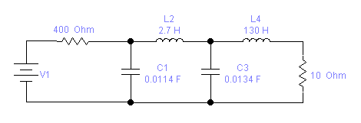 | 7  8
3. | - List the properties of lossless ladder. Realize a 3rd order filter with a maximally flat response for which R_{S} = 1 and R_{L} = 1.  - Design a filter using op amp that provides a set of three 60 Hz voltages of equal magnitude but lagging each other by 120⁰. | 8  7
4. | - Write tuning algorithm for Bi-quad circuits. Design a low pass Tow-Thomas Bi-quad which will provide poles at –577 ± j816.5 and dc gain of 2.  - Compare the sensitivity of the active and passive filter circuits. Perform sensitivity analysis of the Tow Thomas biquad. | 7  8
5. | - Draw a Low Pass sallen and key Bi-quad circuit, find its transfer function and then using RC-CR transformation design a High Pass sallen and key Bi-quad.  - Why Gyrator is used in filter design? Use GIC to design a 3rd order high pass filter with BW response from the filter shown below with cutoff frequency of 75 Hz. Source and load termination Ro = 2.4KΩ.  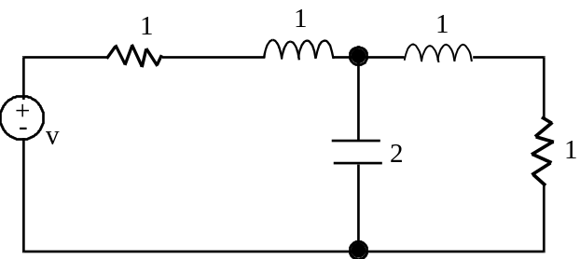 | 8  7
6. | - Simulate the following frequency response using switched capacitor filter. (assume a suitable frequency)  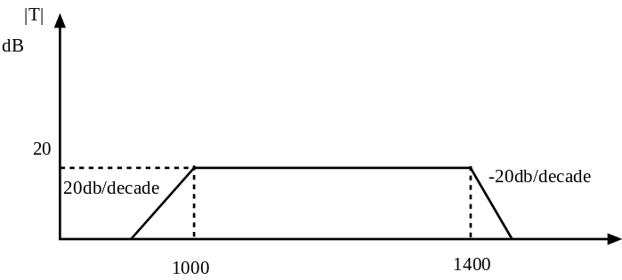freq.  - Design a Butterworth low pass filter using minimum components for the section shown below. The cut-off frequency of the filter is 2π * 1000 rad/sec and use 0.1μF capacitance in the final circuit (use equal elemental value design criteria of sallen and key).  G/(s² + 0.765367s + 1)  V₁ V₂ | 8  7
7. | Write short notes on (Any Two):  - Gain Reduction and Enhancement  - Frequency and Magnitude Scaling  - Cascade realization | 5×2

